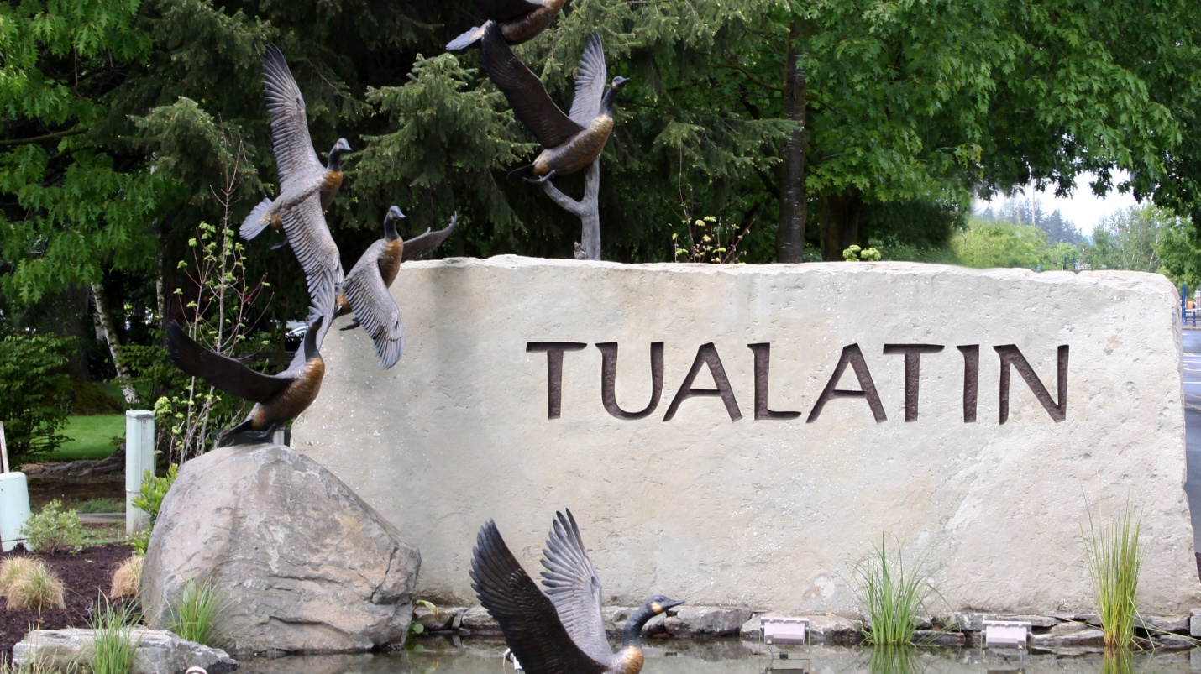

**MANAGEMENT ANALYST II**

***The City of Tualatin, Oregon,*** is seeking a qualified customer service oriented candidate for the position of Management Analyst II.

# *The Community*

The City of Tualatin, population 27,000, is a dynamic, vibrant community ideally located just 12 miles south of Portland and 30 miles north of Salem, the state capitol. Situated at the intersection of Interstate highways 5 and 205, Tualatin is a short distance to adventure: skiing, snowboarding, and sledding on majestic Mt. Hood in the Cascade Mountain Range; family-friendly summer water activities on the central Oregon Coast; national-level wind-surfing or parasailing on the mighty Columbia River, while enjoying the striking natural beauty of Multnomah Falls in the Columbia Gorge National Recreation Area.

Tualatin’s population is well-educated, diverse, and involved in community and school activities. There are excellent educational opportunities available to residents through the Tigard-Tualatin School District and numerous colleges and universities within easy commuting distance. In the most recent resident satisfaction survey, 84% of residents rated the overall quality of life in Tualatin as “excellent” or “good”, and most reported they would recommend the community to others and plan to stay for the next five years. Residents take great pride in and appreciate the amenities such as award-winning parks, unique shopping and dining establishments and a low tax rate.

# 

The city features a balance of high-quality residential areas, along with multiple commercial and industrial zones. Tualatin is a mid-sized city with a big city attitude and spirit. Tualatin is one of Oregon’s most livable cities; a 30-year Tree City USA, it has an extraordinary landscape, painted with charm, opportunity, and accessibility. The center of downtown is anchored by a public/private plaza project, Tualatin Commons, which consists of mixed-use buildings surrounding a three-acre public lake.

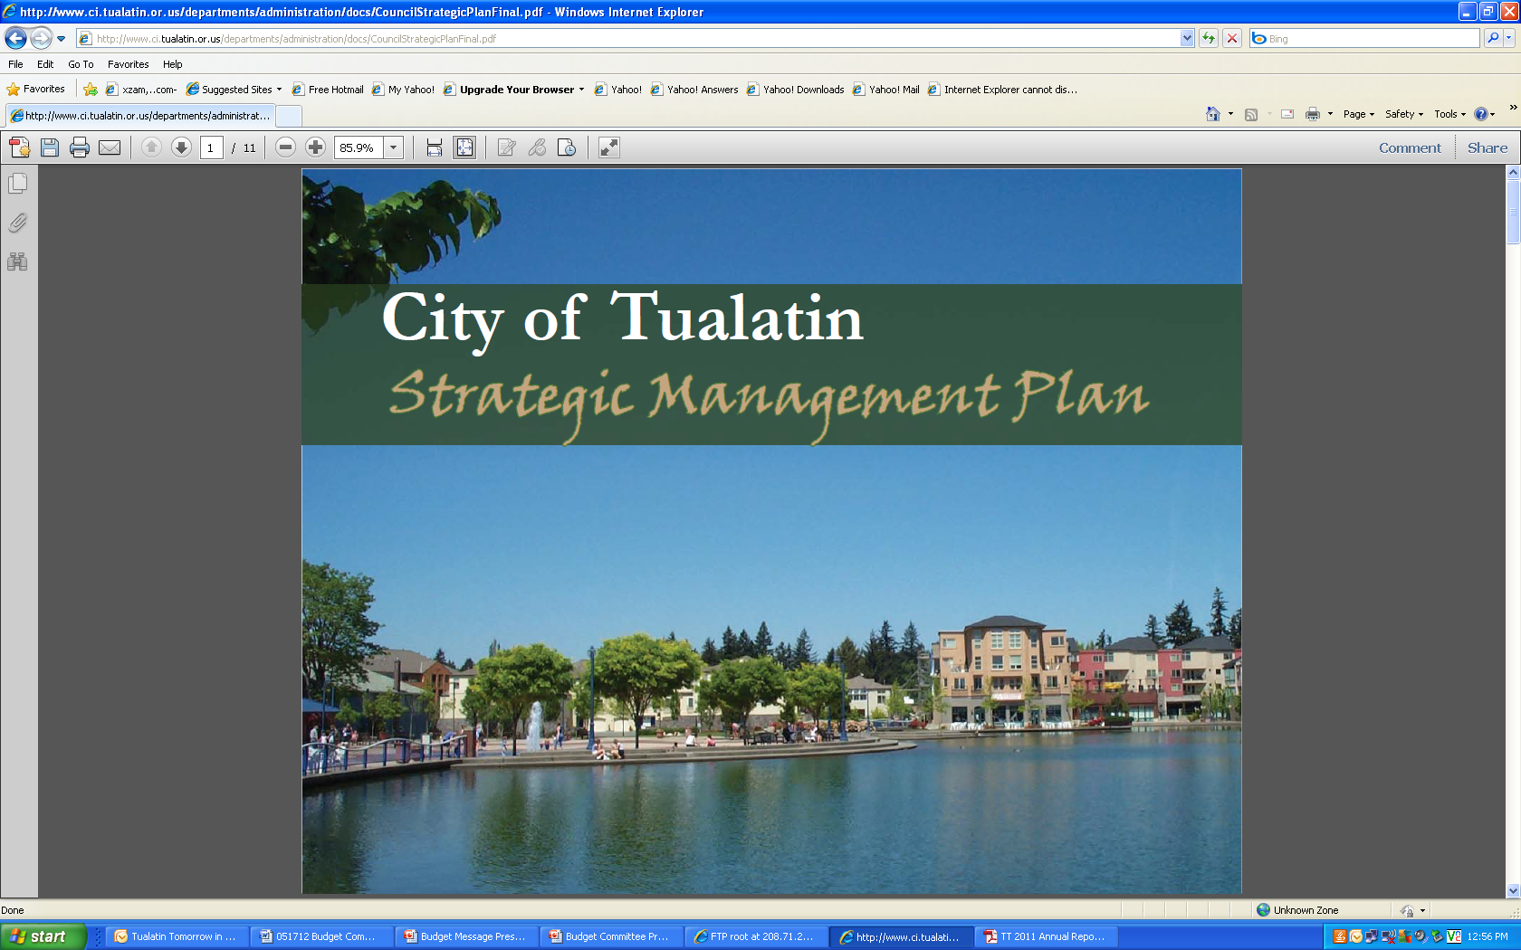

# Large employers include Legacy Meridian Park Hospital and LAM Research. The Portland Trail Blazer’s basketball practice facility and the corporate headquarters of DPI Specialty Food Enterprises are examples of diverse enterprises in the city. Bridgeport Village and The Pointe at Bridgeport are award-winning life-style centers, offering outstanding shopping and restaurant opportunities to the region.

# photo 1.bmpphoto 3.bmp Q:\Recruitment Pictures\BPV_main.jpg

# *The Organization*

The City of Tualatin is organized under the Council/Manager form of government, with the City Manager serving as the administrative head of the organization. The current City Manager has served since December 2006 and is only the organization’s fourth City Manager. The City has a history of progressive leadership with stable and civil governing bodies, and a commitment to improving the quality of life through well-managed, responsive city services, and a record of fiscal prudence.

The organization is made up of 20 divisions within seven departments responsible for all services except fire, which is provided through a special district, Tualatin Valley Fire & Rescue.

The Public Works Department is comprised of Engineering, Streets, Sewer and Storm Maintenance, and Water Divisions, led by the Public Works Director. The Management Analyst II reports directly to the Public Works Director.

*The Ideal Candidate*

The successful candidate will be responsible for coordinating, developing and implementing special projects and programs and conducting financial analysis for the department. Candidates for this position will be polished and professional, with excellent communication and project management skills. These attributes combined with a bachelor’s degree in: Business Administration, Public Administration, Business, Engineering, Planning, or related field coupled with three (3) years of experience in project management, public administration, planning, or rate/cost analysis would make for a nicely rounded portfolio. A Master’s degree would be preferred; however, any satisfactory equivalent combination of education and experience which ensures the ability to perform the work may be substituted for the above.

The ideal candidate should also possess and demonstrate:

* Logical and creative thought processes
* An orientation toward solutions
* Sound decision making with respect to the cost-effectiveness, financial implications, impact and timeliness of projects.
* Integrity, ingenuity, and inventiveness
* Program Management skills for tracking multiple projects
* Confidence, with strong social skills and a networking ability to gather expertise on topics on which they may not have experience
* Adeptness in working proactively with other agency staff and citizens to further the City’s goals
* Effective verbal and written communication skills using both technical and non-technical language
* Well- developed group interaction skills with a willingness to confront challenging issues and dispute resolution skills to help others work through complex issues
* The ability to consider and evaluate alternative viewpoints with an aim towards finding creative solutions by working collaboratively and offering innovative approaches to develop consensus on difficult issues

*Compensation, Benefits, and Process*

***Salary:*** This full-time position has an annual salary range of $**56,492 - $71,593.**

***Retirement:*** The City is a member of the Oregon Public Employees Retirement System. The City contributes the employee’s portion (6%) to the system.

***Benefits:*** The City provides a comprehensive benefits package. For more information, visit the city’s website at [www.tualatinoregon.gov/hr/benefits](http://www.tualatinoregon.gov/hr/benefits).

This position is represented by the Tualatin Employees’ Association.

***Process****:* Applications are received online only by going to [www.tualatinoregon.gov/hr](http://www.tualatinoregon.gov/hr) and clicking on “Job Opportunities.” A cover letter and resume must be included with the online application submission. ***The deadline to apply is 11:59 pm, Sunday, April 29, 2018***. All applicants will be notified of the recruitment status by e-mail (preferred contact) or telephone.

Further steps in the process may include, but are not limited to: interviews, assessment center participation, and a thorough and comprehensive background check. If you need accommodation in the recruitment process, please contact Human Resources at 503.691.3021 or 3022, TDD 503.692.0574, or email to [recruitment@ci.tualatin.or.us](mailto:recruitment@ci.tualatin.or.us)

City of Tualatin

18880 SW Martinazzi Avenue

Tualatin, OR 97062-7092



The City of Tualatin is an equal opportunity employer.